Name: Nehal Patel  
Date: 02/03/2020

Quick introduction on tools

Windows:

1. Take a screenshot of the Windows Task Manager
   1. Click on start (hit the Windows key or lower left)
   2. Type or find snipping tool
   3. Hit Ctrl+Shift+Esc to bring up task manager
   4. Use snipping tool to take screenshot of task manager
   5. Paste here (or attach):

Answer:

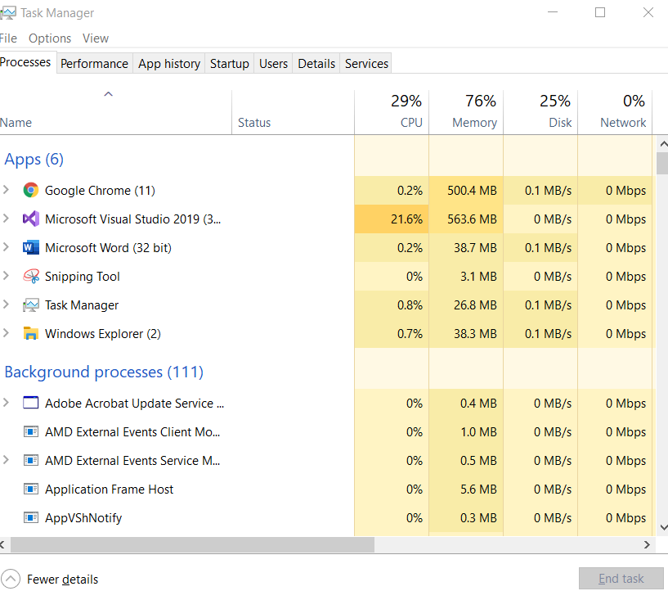

1. Download class sample files from <https://github.com/nadams810/os-70-350/archive/master.zip>
   1. If from zip – extract to a folder
   2. Download external resources from <https://1drv.ms/u/s!AqQfqD9bTAHygsgWo-SozyRs75gbig>
   3. This file is called tools.exe – place this in the ext directory
   4. Double click/extract the files in the ext directory
   5. If the piece of $%#$# “smartscreen filter” prompts you – click more info and “Run anyway”
   6. Go to yourfirstos folder
   7. Double click on make-qemu.bat
   8. Paste screenshot (you just compiled, and ran your first OS)

Answer:

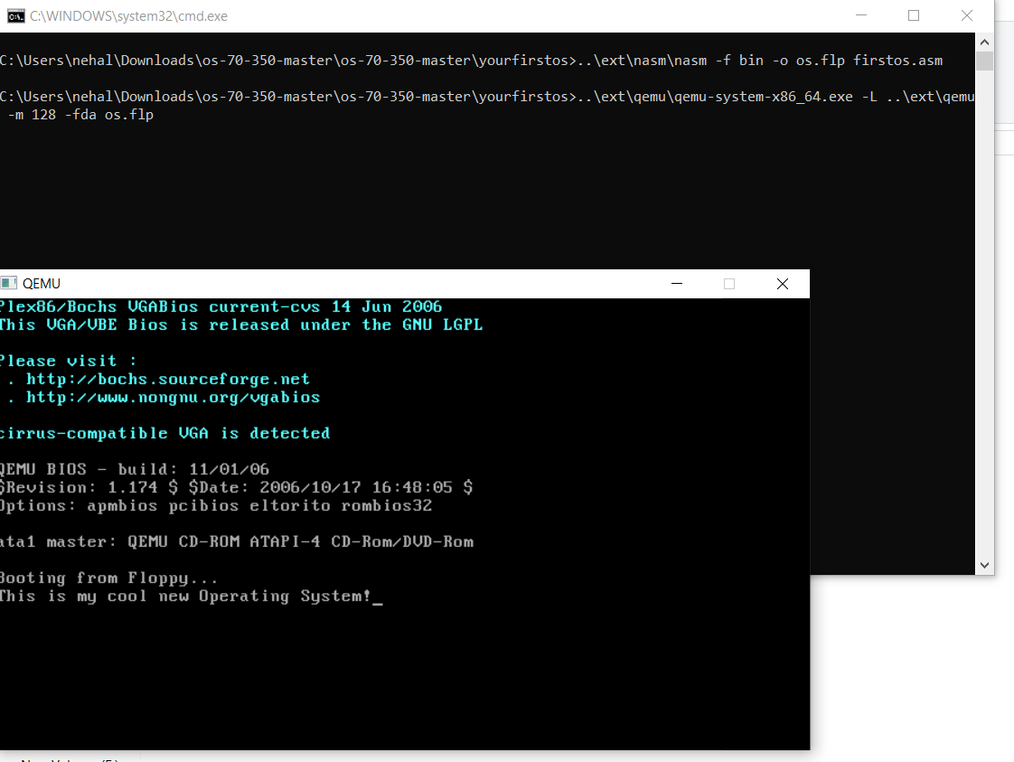

Linux:

The following questions are related to using Linux. You may, and I highly encourage, you to spin up a virtual machine. Amazon does provide a free tier in their EC2 environment. Or you may SSH to the VM setup for the course. Please see the announcements for information on how to connect.

1. From a terminal/SSH client
   1. cd
   2. mkdir os-classcd
   3. cd os-class
   4. wget -O sample.c <http://goo.gl/mhrwr9>
   5. gcc -g sample.c
   6. ./a.out
   7. Does it crash? **Yes**

**Friendly note: I have had so many students throughout the semesters not be able to answer this question. For the love of all that is holy – look at the source code and take your best guess. You can download it with the link above or -** [**https://srchub.org/p/os-70-350/source/tree/master/sample-0/sample.c**](https://srchub.org/p/os-70-350/source/tree/master/sample-0/sample.c)

1. Let’s figure out why
   1. gdb ./a.out
   2. r (for run)
   3. print z
   4. What’s the value of z? **(int *) 0*0**
   5. print i
   6. What’s the value of i? **$2 = 0**
   7. Exit by hitting ctrl+d or type quit
      1. If it asks if you really want to quit – type y
   8. Fix z by either making it a stack variable or allocating/freeing the memory from the heap
      1. z can be any value you want
      2. ie – int z -> stack variable
      3. int * z = (int *) malloc(sizeof(int));  
         /* … code */  
         free(z); -> heap variable
   9. Paste the fixed code below (you can copy/paste out of a terminal window, in putty selecting puts the text into your clipboard automatically):



